**Fraction Fascination**

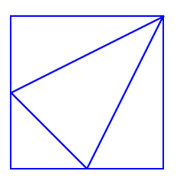

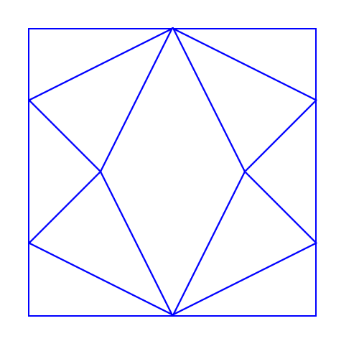  
Can you see four triangles in the square?  
  
What fraction of the area of the square is each of these triangles?  
  
  
What is the shape that has been created in the middle of this larger square?   
  
What fraction of the total area of the large square does this shape take up?